### Unit Test:

|  |  |  |  |  |  |
| --- | --- | --- | --- | --- | --- |
| No | Test Title | Pre-condition | Test Steps | Expected Results | Actual results |
| 1 | Clicking “Information Request” button/link to open a form | Have to go “Online Learning” page from the Nav Menu | Click on the link/button to who result | The result was expected to open the desired form | As expected |

## 

Figure 1: Information request has been clicked from Online Learning page.

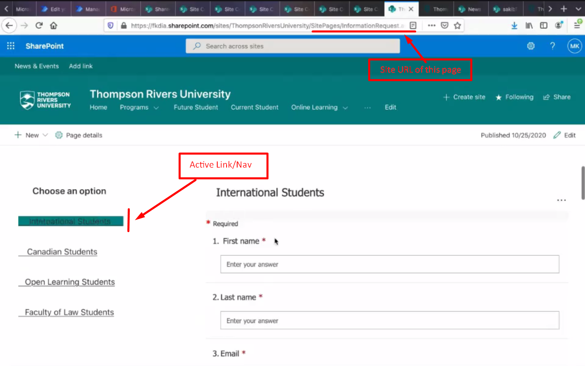

Figure 2: International Student form opened after clicking.